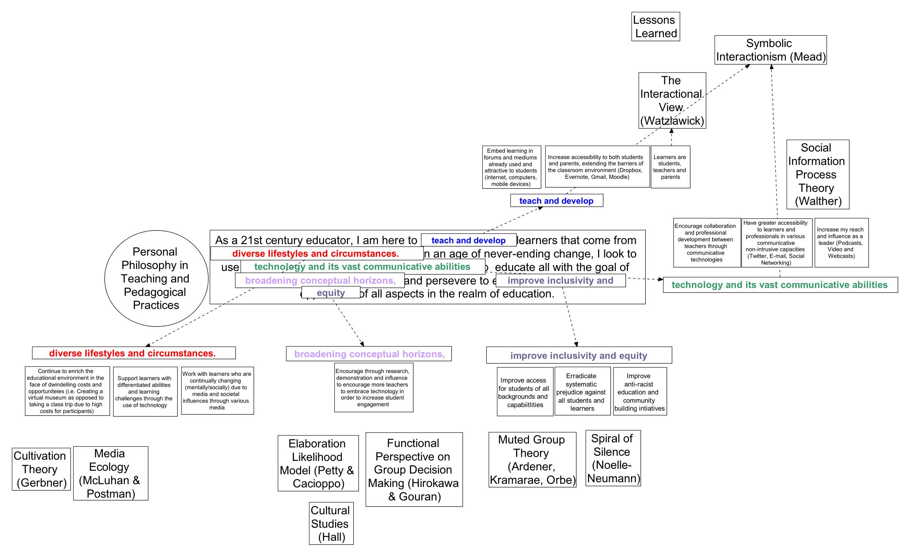

My enrollment in this course was to assist in my development as a promising leader in the field of education. One can only be a leader in this profession if he/she were to be an exemplary teacher. I am trying tirelessly to be that teacher by increasing student engagement through the use of technology in my instruction and assessment. Currently in education, the climate around student engagement through technology is both bustling and controversial. By learning and analyzing various communication theories, I predicted to come out of this course with the abilities to not only implement good teaching practice through the use of technology in my classroom; additionally I would have strong scholarly theoretical ideas and analysis to back up my initiatives that use Information and Communication Technologies (ICT). My practice is driven by my own philosophy of teaching . It is as follows:
As a 21st century educator, I am here to teach and develop learners that come from diverse lifestyles and circumstances. In an age of constant change, I look to use technology and its vast communicative abilities to educate all with the goal of broadening conceptual horizons, and to improve inclusivity and equity of all facets in the realm of education. This is not a thesis – this is more or less a mission statement. The mind-map that compliments this learning review should be used as a reference for what communication theories supported my mission statement, however this review shall explicitly state how they support it.
Highlighted components in philosophy can be seen on the mind-map. They are: teach and develop, (learners) diverse lifestyles and circumstances, (use) technology and its vast communicative abilities, broadening conceptual horizons, and improve inclusivity and equity (in all facets of education).
My ability to teach and develop learners is not exclusive to students. I look to educate and inform adults, from parents to colleagues. To communicate my ideas, I need to tap into a myriad of mediums; print, online, video, audio, instant messaging, just to name a few. Much of the content I would have to share may often be new or foreign to the thinking of my audience. Implementing the ideals of Watzlawick’s Interactional View (1967). I have to maintain the idea that with much of my communication being digital, I will be participating most often in complementary communication. I also invite the opportunity for the communication to be symmetrical and become a constructive discourse between myself and other(s). When introducing all these new avenues of communication and access between students, parents, and others, I had to weigh out the possible drawbacks and risks that could come of these initiatives (emotionally charged conversations, labeling, harassment, etc.). Following the analysis of Mead/ Blumer’s Symbolic Interactionism (1967), I know that I have to demonstrate effective communication between persons in my classroom. Furthermore, I have to be weary of how I communicate my thoughts to parents in digital and written communications.
The 21st century learner is a diverse prototype that has characteristics that can not be attributed to every student; one student is different from the other. One method may work with one, and not with the other. Aside from the variance in cultures, backgrounds and life experiences (which I generally took into account in the past), this course has brought to the forefront of my thought that the influences being communicated to students through mass-media are also influences an educator must take into account when working with today’s youth. Gerbner’s Cultivation Theory (1980) and McLaun & Postman’s contribution in Media Ecology are eye-opening theories. Though there is some strong critique to refute the theories in certain aspects, both definitely hold some clout. One can see aspects of the “Mean World Syndrome” (Cultivation Theory) in the actions and dispositions of certain students inundated with television and video game violence in their free-time. To contest the media’s impact on society is arguably ignorant at this point. I myself am a fan of Neil Postman’s writings (especially Amusing Ourselves to Death). His texts had foresight on issues that didn’t come to fruition until 20 years following the book’s publication. In my plans to do further work with students of this generation, I will have to take notice of the trends apparent in their behaviour. It will be these two theories that I will refer to in order to draw a greater understanding of media’s influences in the past, and perhaps in the future.
The asset I wanted to come out from this program was an increased repertoire of different forms and mediums of technology in order to communicate in an educational context. Though I may not have got that from the various theories shared in our course, I did from the lessons shared by the course instructor, Maggie McPherson. Her lesson on institutional learning environments has allowed me to essentially put a title to a platform. In my pursuit to become a leader in technology in my school board, this knowledge will build on my understanding of various systems of communication technology. Consecutively, it will also allow me to work on reducing the drawbacks and current inequities the platforms pose to various learners. They are outstanding concepts that may need to be updated or accommodated to meet the needs of present and future participants. With that said, the theory I first presented in this course on Walther’s Social Information Theory brought to attention how social interaction and discourse has taken new forms and precedence in the present more so than any other time before. To see the benefits from synchronous and asynchronous communication in learning environments, and the learning and support that can be attained in such forums as chatrooms, blogs, posts, and wikis were eye-opening. It was something I analyzed a year too late as many of the points I found in my research for that presentation would have been useful in my defense for the tech initiatives I attempted to start in my classroom last year. There was quite a bit of parent pushback. Nevertheless, my goals for the future lay in increasing collaboration and professional development among teachers through the use of communication technologies and social networking. This is my attempt to broaden conceptual horizons. I am sure delving more into Social Information Process Theory will assist me in my work.
A major component so it seems in communication is the idea of persuasion. Communication technology (and technology in general for that matter) is currently still on the cusp of being widely accepted by teachers in the profession. Theories such as the Elaboration Likelihood Model (Petty and Cacioppo), Functional Perspective on Group Decision Making (Hirokawa and Gouran) and Cultural Studies (Hall) all have an element of persuasion to them, that I will have to analyze with greater scrutiny when I work with other teachers who may be hesitant to include new technologies into their practice. With a strong theoretical backing to my ideas and concepts, the previously mentioned theories of influence will hopefully assist in my pursuits to encourage change and discourse regarding increasing student engagement with technology.
Finally, the piece that concludes my philosophy is also the piece that I want to linger in the minds of both myself and those who read it, and that is to improve inclusivity and equity in the realms of education. Among other structures in (North American) society, education is a structure that has a history of having inequities at numerous levels, systematically affecting individuals and students within it. Education can suffer from the same inequalities and inequities as corporate businesses and levels of government. Noelle- Neumann’s Spiral of Silence and Ardener/ Kramrae’s Muted Group Theory lay out different phenomena as to why and how through forms of communication, disenfranchised groups are marginalized. The various subtle and obvious nuances that all have to do with communication are astounding, and if I grasp these ideas with a thorough understanding, I will be better able to see biases (hidden and overt) in texts and media. I was most fascinated how the theory of the Muted Group idea has progressed from it being from a feminist perspective to a minority/ racial group perspective (Orbe’s “Cross-Cultural Muted Group Theory”). Furthermore, a development I made without deeper research (but am now interested in) is the rise of dominant group pushback and disagreement with the shift occurring in power among groups. Inclusivity and equitable treatment, to some, is diverting from the main stream (norm), and that is creating discomfort among many who were benefitting from their membership in the dominant group. This will definitely be an aspect I will be giving further attention to as I continue to work on my portfolio. I often read articles of individuals with such critiques in the media. I now feel empowered in contesting and scrutinizing these individuals from my understanding of these communication theories. In retrospect to the theories in this category of my philosophy, I admit that I see myself as an individual that participates in the Spiral of Silence in a completely opposing way. As an outspoken individual, regardless of moral or overt support (and opposition) I voice my opinion. Granted my physical safety is not in jeopardy, I voice my opinion especially if I am in a minority in a dominant group situation. Additionally, all aspects that change human behaviour affect me in a converse manner. For example, I have no fears of isolation based on my opinion (often I am the only one that shares my opinion) especially among topics that are not status quo. An example is my criticisms of various countries that subscribe to the movement known as the “War Against Terror”. Seeming to be a altruistic and moral movement, I have sharp criticisms of the very basis of it; these not popular sentiments to have in the main stream. Additionally, the idea of pluralistic ignorance is far from my schema and influence. Personally, I question this theory when analyzing the behaviour communication of those who unquestionably contend with the dominant majority. Individuals that come to mind are Muhammad Ali, Malcolm X, Ralph Nader and Martin Luther King, to name a few. These individuals unquestionably spoke against mainstream thought. As long as I conduct myself in a calm, educated and informed manner, I feel that I can continue to speak out against dominant opinions without worry for my position as an educator or member of society.
I am left at the end of this course pondering where do I go from here with the knowledge I have attained. Additionally, what knowledge am I not going to take with me? In all humility, though I am content with the many theories I have been introduced to, as a learner, I was not ecstatic about the format of the course. I grew tired of the research/present format, however, I enjoyed learning about all of the theories. I believe perhaps I may have enjoyed it more if we were not an online synchronous class, for I feel we missed out on the human interaction that is quite intriguing in-group work and presentation sessions. This didn’t take away from the learning; it just hindered my preference for direct human interaction in learning environments. Nevertheless, I do believe with busy schedules and physical location of individuals becoming an integral setback regarding access to educational opportunities, communication technology is the solution. I will focus as an advocate for communication technology by asking, “how can I minimize the digital divide”; because I believe there is one. In collaboration with innovative ideas such as One Laptop Per Child (OLPC), I think the digital divide can be minimized if collaborations between corporations and educational institutions occur with my question in mind. This is a jump-off point for me as an educator. It may be what I focus on in my portfolio development. A great deal has to be taken into account; however, communication technology is a realm that I believe will present numerous opportunities for innovation in the years to come. The information I have gained from this course is the initial step in my long path towards making a noticeable impact in the realm of education.

